Practical 1
import numpy as np

# Spreading codes
c1 = [1, 1, 1, 1]
c2 = [1, -1, 1, -1]
c3 = [1, 1, -1, -1]
c4 = [1, -1, -1, 1]

rc = []

print("Enter the data bits:")

d1 = int(input("Enter D1: "))
d2 = int(input("Enter D2: "))
d3 = int(input("Enter D3: "))
d4 = int(input("Enter D4: "))

# Multiply data with spreading codes
r1 = np.multiply(c1, d1)
r2 = np.multiply(c2, d2)
r3 = np.multiply(c3, d3)
r4 = np.multiply(c4, d4)

# Resultant channel signal
resultant_channel = r1 + r2 + r3 + r4
print("Resultant Channel:", resultant_channel)

# Select receiver code
Channel = int(input("Enter the station to listen for (C1=1, C2=2, C3=3, C4=4): "))

if Channel == 1:
rc = c1
elif Channel == 2:
rc = c2
elif Channel == 3:
rc = c3
elif Channel == 4:
rc = c4
else:
print("Invalid channel selected")
exit()

# Inner product calculation
inner_product = np.multiply(resultant_channel, rc)
print("Inner Product:", inner_product)

res1 = sum(inner_product)

data = res1 / len(inner_product)

print("Data bit that was sent:", data)

OUTPUT
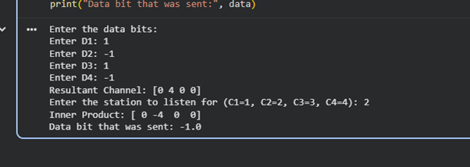

Practical 4
clear

N = 10^6; % number of bits or symbols

rand('seed',100); % initializing the rand() function
randn('seed',200); % initializing the randn() function

% Transmitter
ip = rand(1,N) > 0.5; % generating 0,1 with equal probability
s = 2*ip - 1; % BPSK modulation 0 -> -1; 1 -> 1
n = 1/sqrt(2) * [randn(1,N) + j*randn(1,N)]; % white gaussian noise, 0dB variance
Eb_N0_dB = [-3:10]; % multiple Eb/N0 values

for ii = 1:length(Eb_N0_dB)

% Noise addition
y = s + 10^(-Eb_N0_dB(ii)/20) * n; % additive white gaussian noise

% receiver - hard decision decoding
ipHat = real(y) > 0;

% counting the errors
nErr(ii) = size(find([ip - ipHat]),2);

end

simBer = nErr / N; % simulated ber
theoryBer = 0.5 * erfc(sqrt(10.^(Eb_N0_dB/10))); % theoretical ber

% plot
close all
figure
semilogy(Eb_N0_dB, theoryBer, 'b.-');
hold on
semilogy(Eb_N0_dB, simBer, 'mx-');
axis([-3 10 10^-5 0.5])
grid on
legend('theory', 'simulation');
xlabel('Eb/No, dB');
ylabel('Bit Error Rate');
title('Bit error probability curve for BPSK modulation');

OUTPUT
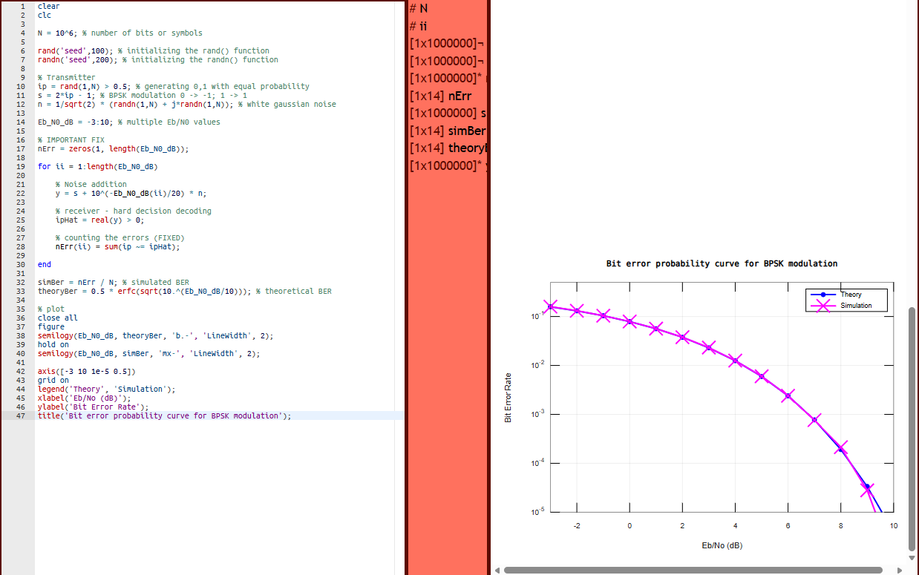
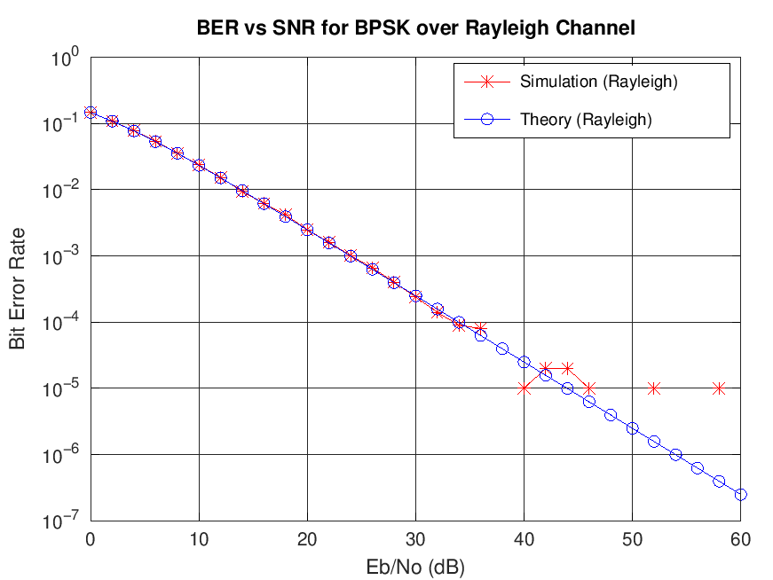

Practical 5
Network consisting of router, switch and end devices
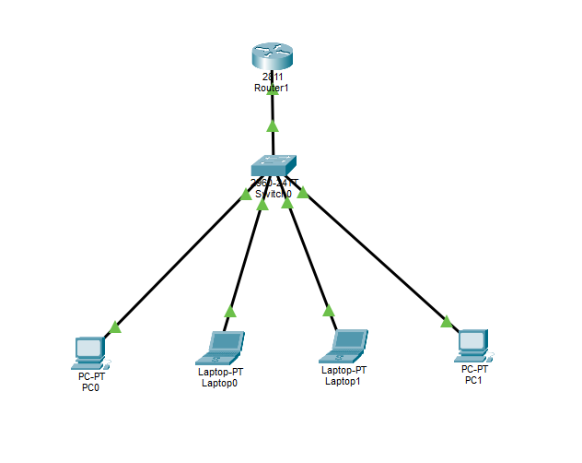

Configuring the router as a DHCP Server
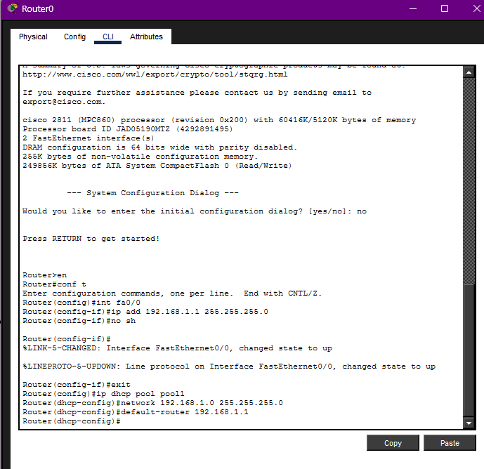

Assigning IP Address using DHCP
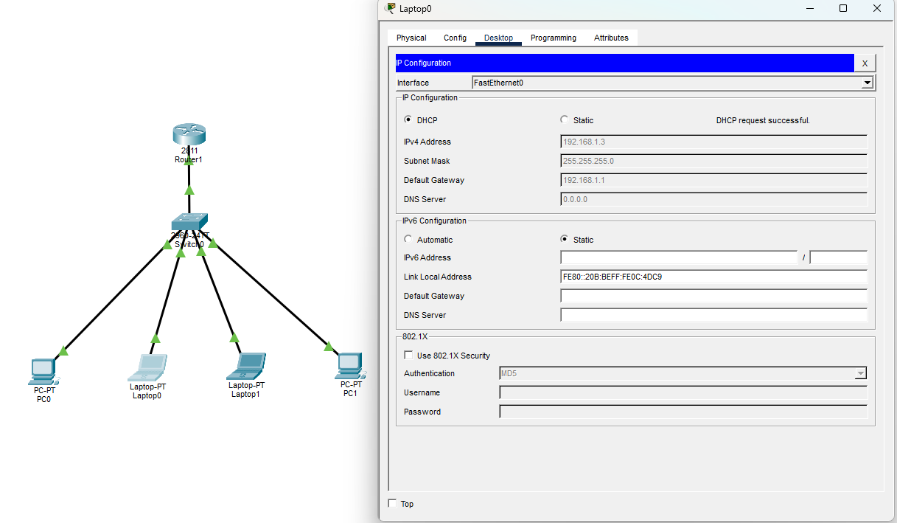

DHCP Server Practical:
en
conf t
int fa0/0
ip add 192.168.1.1 255.255.255.0
no sh
exit
ip dhcp pool pool1
network 192.168.1.0 255.255.255.0
default-router 192.168.1.1

Practical 8
Configuring FTP on the server:
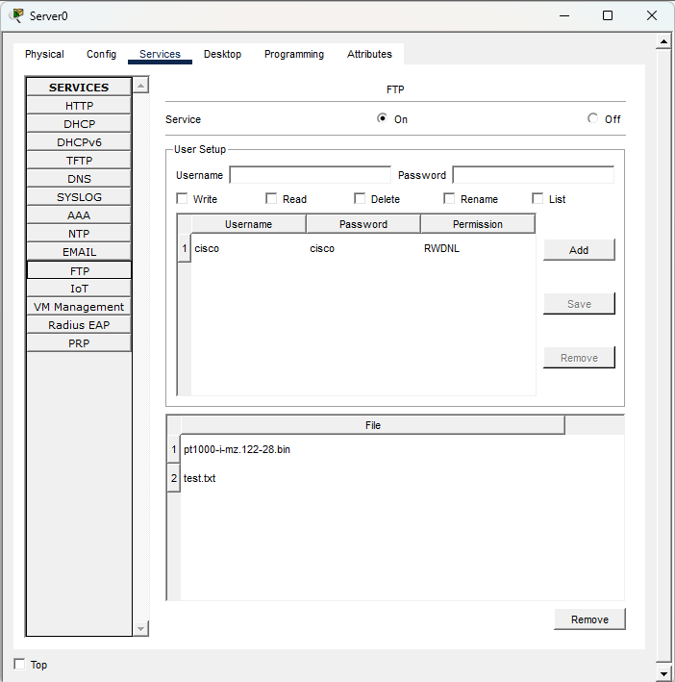

Sending files from Laptop to server using FTP
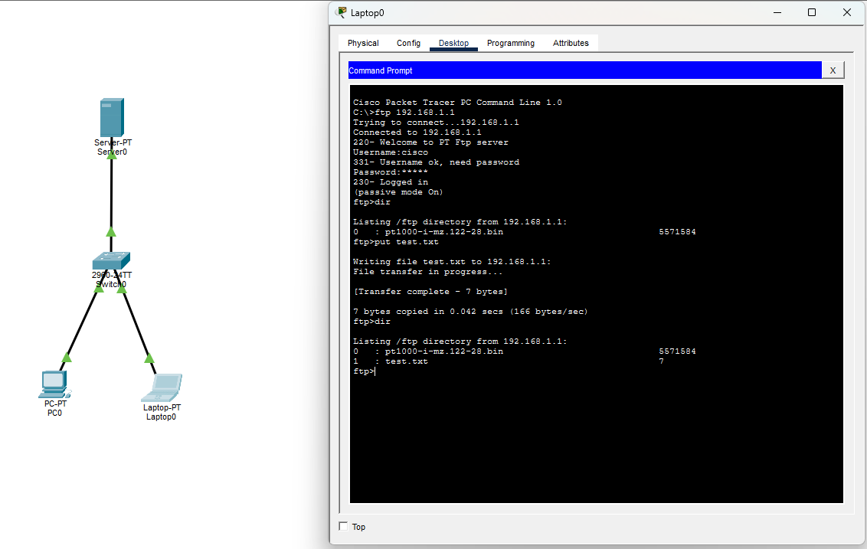
FTP-
ftp 192.168.1.1
username:cisco
password:cisco
dir
put test.txt
dir

Sending files from Laptop to server using FTP using python
├── server.py
├── client.py
├── abc.txt
-----------------------------------------------------------------
| SERVER.PY |
-----------------------------------------------------------------
import socket, os

os.makedirs('received/', exist_ok=True)

conn, _ = socket.create_server(('0.0.0.0', 5001)).accept()

# Receive filename and size
filename = conn.recv(4096).decode(); conn.send(b"ACK")
filesize = int(conn.recv(4096).decode()); conn.send(b"ACK")

# Receive and save file
with open(f'received/{filename}', 'wb') as f:
received = 0
while received < filesize:
chunk = conn.recv(4096)
f.write(chunk)
received += len(chunk)

print(f"Saved '{filename}' — {received} bytes")
conn.close()
-----------------------------------------------------------------
| CLIENT.PY |
-----------------------------------------------------------------

import socket, os

FILE = 'data.txt'

client = socket.create_connection(('127.0.0.1', 5001))

# Send filename and size
client.send(os.path.basename(FILE).encode()); client.recv(4096)
client.send(str(os.path.getsize(FILE)).encode()); client.recv(4096)

# Send file
with open(FILE, 'rb') as f:
while chunk := f.read(4096):
client.send(chunk)

print(f"Sent '{FILE}'")
client.close()
